**Website Report**

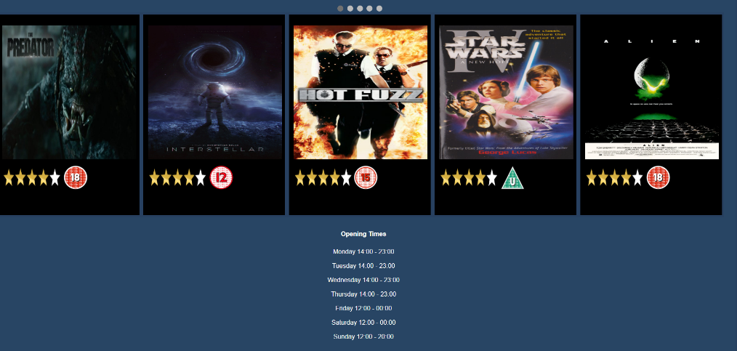In this report I will outlining the important and clever things I have included in this webpage design. This report will include snips of the webpage as well as the annotated code.

**Organisation of the Webpage**

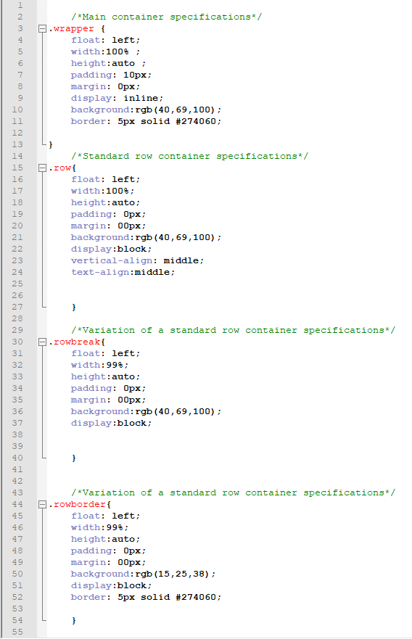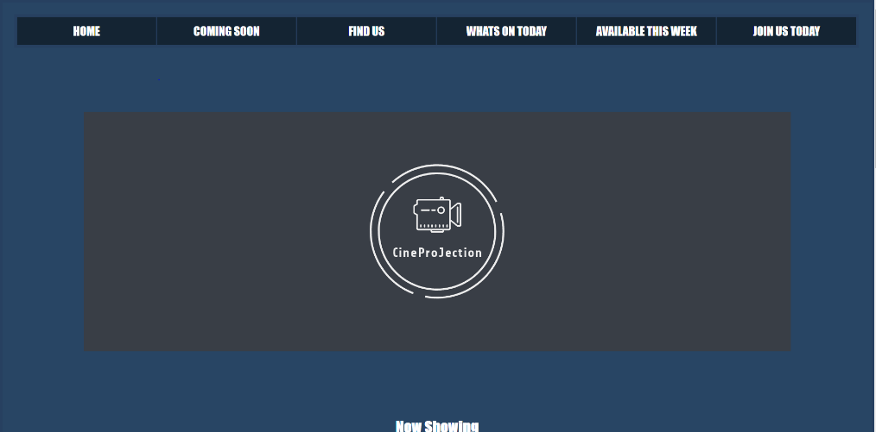

The webpage that has been designed has been written in Notepad ++. Each individual webpage designed has been saved into its own html file. There is also a CSS style sheet where all the CSS has been drawn from. It is drawn with the code shown above. Finally, there is a JavaScript style sheet where all the JavaScript that is required for the webpages will be drawn from.

The web page is broken down into several boxes which form was used to form the structure of the webpage.

The image above on the right-hand side in the annotated code shows some of the box structural code which has been drawn from CSS. There are four box types shown all of which do a slightly different thing, they are, Wrapper, Row, Rowbreak,rowborder.

The wrapper for example is the main box of the webpage, all other boxes will be placed inside this one. It contains several clever commands which give the design for the box which are between the { }.

**Float**: This will float the contents in the direction requested.

**Width**: This command gives width to the box this can be done with percentage or pixels.

**Height:** This command gives height to the box this can be done with percentage or pixels.

**Padding**: This command gives padding around the box this can be done with percentage or pixels.

**Margin:** This command gives a margin around the box this can be done with percentage or pixels.

**Display:** This command specifies the display behaviour of a element.

**Background:** This command gives colour to the background, this can be done by typing the colour, hex number or RGB number. Images may also be used for a background.

**Border:** This command specifies the colour

The box named “row” also has more clever commands to help give the boxes direction.

**vertical-align**: This command aligns the contents of the box using the vertical axis depending on where the user wants the contents to be displayed.

**Text-align:** This command aligns the text into the box where the user wishes it to be displayed.

**Navigation Bar**

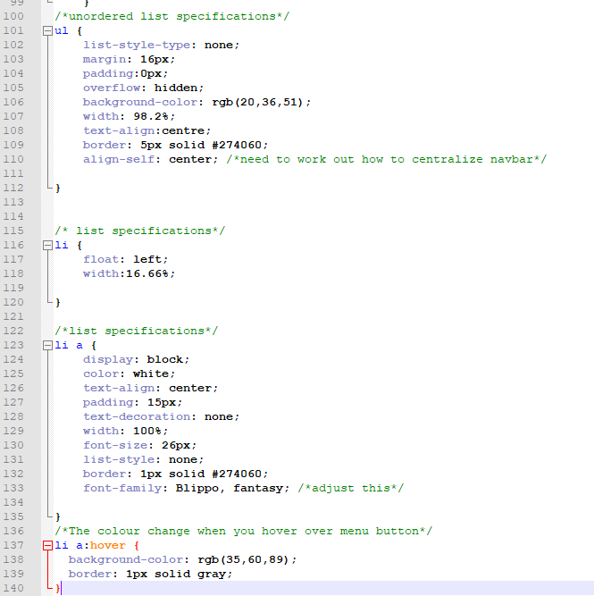

The navigational bar requires some CSS commands which again are drawn from the CSS page with the code shown above.

Ul stands for unordered list.

LI is a list item in an unordered or ordered list.

These organise the navigation bar and you can use these to design your navigation.

The clever CSS included in these are:

**List-style-type**: This command specifies the type of list-item marker in the list.

**Overflow**: This command specifies what should happen if the content overflows a element

**Align-self:** This command specifies the alignment for the selected items inside the container, this property will override other align item functions.

**Color**: This command changes the colour of the text in the container

**Text-decoration:** This command specifies if there is any decoration to be added to the property.

**Font-family**: This command specifies the style of the font.

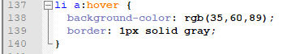Finally, the final clever detail with the CSS is the hover part of the list, with this function you can change the features of the button the user is hovering on such as changing colours or adding a border.

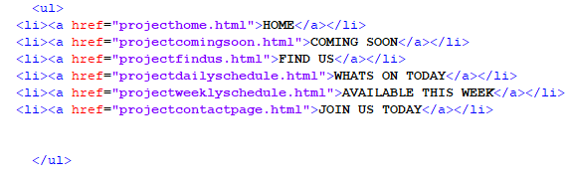The HTML also includes some clever code for the webpage, it is the HTML which allows the buttons to be hyperlinks which will link the navigation bar with other pages. The href makes the button active to the page that is put into the “ ”.

**Slideshow**

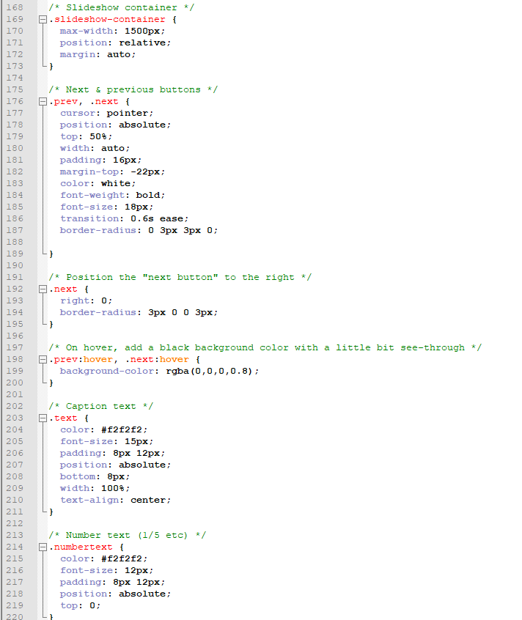The slideshow like the navigation bar uses CSS and draws it from its file the same way. The slideshow however also draws from the java sheet as shown below. This allows all the Java Script to be put all in the same place.

Included in this code is the next and previous button for the slide show additional CSS is used for it.

**Position**: Using this property specifies the type of positioning method used for element

**Cursor:** This property specifies the mouse cursor to be displayed when pointing over a specific element.

**Top:** This property affects the vertical position of the element

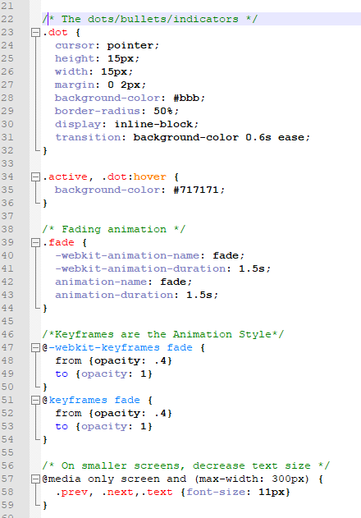**Font-weight:** This property sets how thick the characters of text are.

**Font-size:** This property sets the size of the text.

**Transition:** This allows a property change smoothly to another.

**Border-radius:** This allows the user to define the radius of the element’s corners.

Included below the slideshow are bullet points which when clicked change the image on the slide show, the CSS used for this have been mentioned above.

Furthermore, included is the code for the fade animation the code. The fade code used is all for the design of animation used and the duration it takes to fade.

Finally, a final bit of code at the end of the screenshot to the left is to target certain properties of the code to adjust the slideshow to adapt to a different size screen.

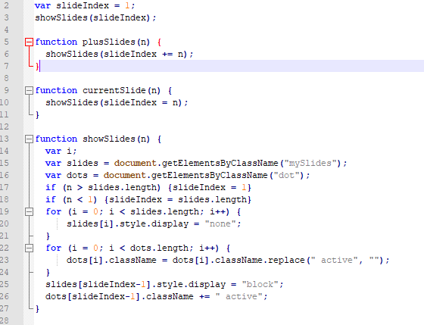The screenshot also calls for clever code in the JavaScript which is shown to the right.

This code allows when the image on the slideshow is clicked to swap to the next image on the slideshow.

Clever individual elements in this code are for example:

**getElementsByClassName:** Which returns a collection of elements in the document with the specific name requested.

**++:** This adds one to the variable, these are normally used in lists to move on to the next item in the list.

**Image Hyperlinks**

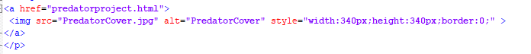The clever code in the image hyperlinks is like the HTML in the navigation bar, but it in this the hyperlink relates to the image so when the image is clicked this will direct the user to the correct page. There is additional clever code here in here with the CSS style that adjusts the size of the image to make it fit inside its designated box.

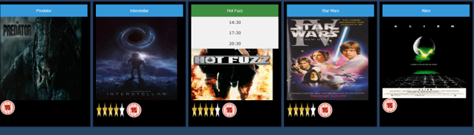**Dropdown Box**

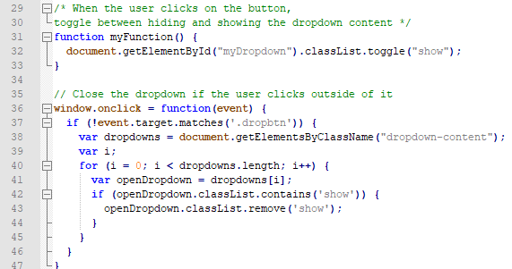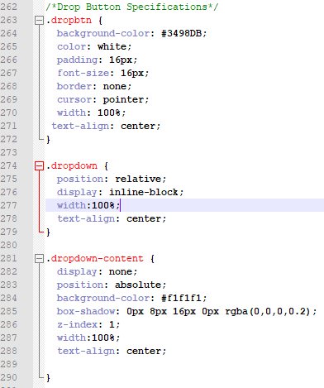The dropdown box is like navigation bar it requires clever code in the HTML, CSS and JavaScript. New CSS paragraphs are used for this, but no new code is required that has not already been explained above. The clever HTML in the dropdown box is the hyperlinks used on the individual boxes in each dropdown.

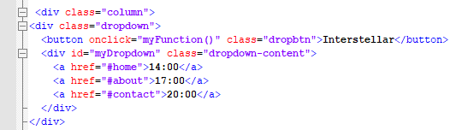The JavaScript in this code is also basic code that has been used with the navigation bar such as “getElementsByClassName” and “i++.”

